**Tips on how no-code tools can help a small business automation**

No-code automation tools handle processes that exist across a business and use software to automate those processes, freeing up valuable term and resources. They are generally used to remove important but manual and repeatable jobs, such as beginning order verification messages, automatic file transfers, marketing notifications updates sending or report generation, and allocation.

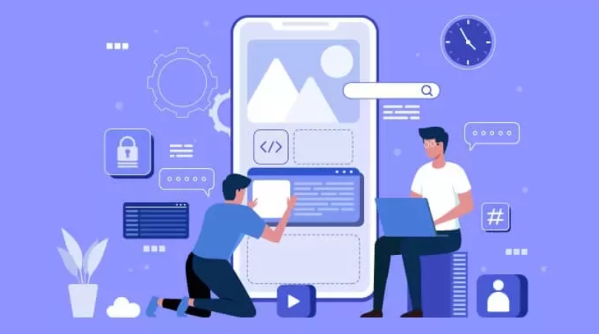

**Do small businesses use automation?**

Still, managing your small business by hand? At best, you’re looking at a grueling process that eats at your time, money, and resources.

Every small business handles its inventory differently, which is why this step-by-step guide is here to provide you with everything you need to create a custom small business management process that works for your organization. Build your business management app from scratch with zero coding and use it to automate your inventorying workflows.

You can use apps to automate your small business management process to make it more efficient. Inventory apps can help you keep track of raw materials, manage your business levels, conduct demand forecasting, and so much more.

If you’re an eCommerce inventory, apps can also help you market your products directly to your customers with small business management features built straight into your online store. You can effectively automate all your supply chain tasks from acquiring materials to delivering goods using a single platform.

There's more scope for automation in your small business than ever before. With automation, you can schedule emails to be sent at the perfect time, follow up with leads that have abandoned their cart, sync data between apps, and notify team members of new tasks.

As a small business, you need to know exactly who you are marketing to. Knowing who your unique clients are allows you to generate sales effectively, and marketing automation tools for small businesses, in turn, allow you to reach those unique clients more easily.

Someone once said, "If you fail to plan, you plan to fail." A marketing strategy is an essential milestone in the life of any small business. It allows you to take your goals, strategies, and tactics and put them on paper. After all, your marketing plan is the heart of your small business. It's where you figure out what you will do and how you hold your squad accountable. And it's how you make sure you have everything covered.

A successful marketing strategy is a powerful tool that gives your small business direction over the upcoming months. It helps you keep track of the critical things you need to do and can also help keep you focused. This blog will cover the most vital elements necessary in any marketing strategy.

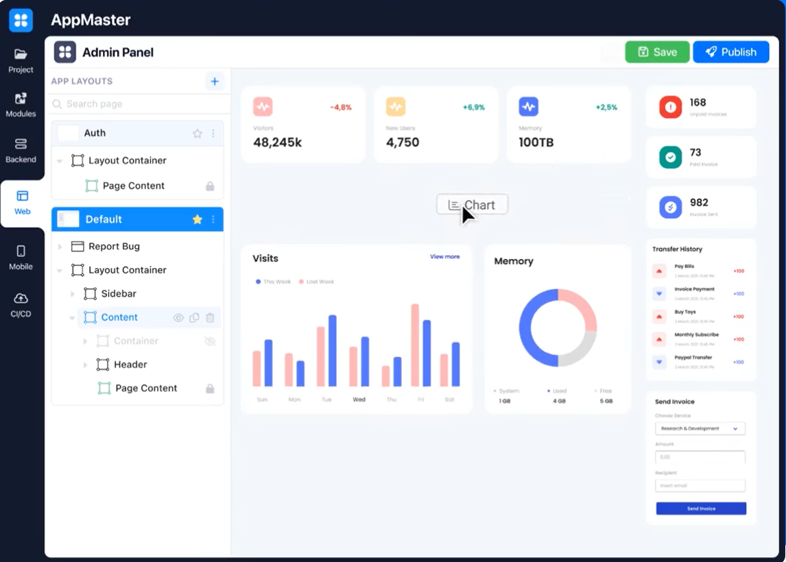

**What is an example of automation in business?**

Business process automation lets organizations streamline critical processes to reduce the complexity of handling multiple tasks for one process. While automated process automation focuses on software robots that manage individual tasks that mimic human interaction, Business process automation takes a big picture approach to improve efficiencies throughout your business.

Examples for automating your business:

**Automated File Transfers**

Automate offers a comprehensive automated file transfer solution that makes managing a high volume of file transfers simple and easy to use.

Organizations frequently move hundreds or even thousands of files everyday. Basic file transfer tools can be reliable on a small scale, but larger companies require a more sustainable solution.

**Browser** Automation

Website automation is a way to automate common web actions—like filling out documents, clicking on buttons, and downloading files—and hands them over to helpful software bots. Automate’s web browser automation functionality features an intuitive drag-and-drop interface so IT and business users can fast and easily automate browser actions without writing a line of code. Use Automate to integrate web automation with your overarching automation plan.

**Automated User Provisioning**

Various applications need to be provisioned when a new hire joins, possibly with different permission settings for each hire. Business process automation software can automate these HR processes while keeping all relevant groups notified at each stage.

**Automated Report Generation and Distribution**

Automate's report automation feature eliminates the need for manually generating reports, reducing the possibility of errors, and freeing up your analysts to do what they do best to analyze the data.

Go beyond automated reporting and make the entire process efficient by tying it into processes like PDF scraping or writing the reported data into an accounting system.

**Automated Order Entry**

To make informed, strategic, decisions, an organization needs data. Most businesses know this and are collecting data from more sources than ever. However, just collecting the data isn’t enough—sometimes there are logistical obstacles to accessing and using essential business data. For example, data can be tied up in PDF documents, which are notoriously difficult to manipulate. Another obstacle to making full use of your data is if interacting with databases—entering the data, extracting it, moving it—is too time-consuming. Employees’ hours should be spent on analyzing your data and acting on the data, not on keying it manually into a database.

**Email Automation**

An email has become the main way of communication for small businesses around the world. It is essential to so many parts of your organization, but sifting through the inbox takes up valuable time.

Many organizations look to automation for specific parts of their email processes to serve customers more efficiently and allow humans to focus on the messages only they can handle.

Use Automate for email automation with your overarching enterprise automation plan.

**Cloud Automation**

In the last decade, cloud computing has developed from the newest IT buzzword to a critical technology powering the digital transformation of companies. Migrating systems and applications to the cloud allow for lower prices, faster implementations, and greater scalability.

Automating your mixed environment doesn’t have to be complex. Automate can be deployed on-premise or in the cloud, and can connect to and centralize your systems and applications.

[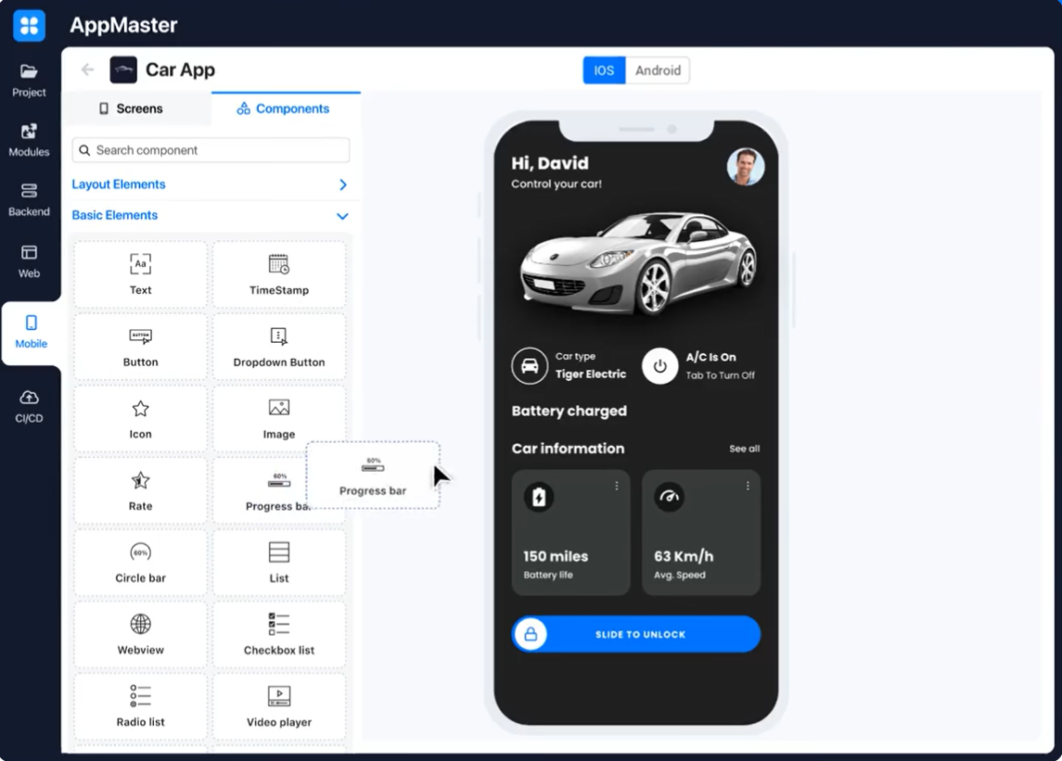](https://appmaster.io/)

**Can you fully automate a business?**

Yes, of course, anyone can automate their business.

Fully automated means that the business information system is expected to perform the activity from beginning to finish without user involvement. A simple example is the system automatically posting a monthly payment against client accounts. A more complex example is the system utilizing customer-specific pricing facts to determine the amount charged for a purchase made by a client.

A fully automated small business is a enterprise that has eliminated the need for human employees to complete all or most of its tasks. Automation typically refers to the use of devices and software to carry out tasks that have traditionally been done by people, such as manufacturing products or answering client inquiries.

A fully automated business can be run with a very small staff or even no staff at all. For example, a company could use robots to assemble its products, computer programs to answer client emails, and automatic billing systems to process payments. Alternatively, a business could outsource all of its operations to other organizations that specialize in automation.

If you need to build automated workflows, [AppMaster](https://appmaster.io/blog/what-is-visual-programming-and-how-does-it-work" \t "_blank) should be your new best friend.

While working with a web application, the user sometimes needs to receive feedback notifications, for example, about successful saving/updating of data, completing some procedures, or an error that occurred.

The Show Notification block is responsible for displaying notifications [AppMaster](https://appmaster.io/" \t "_blank) web applications. You can find it in the frontend Businness process editor, under App Action.

With this block, you can customize the title and text of the notifications, the type of notifications, choose where to place the notifications on the page, and the length of time for which the notifications will be displayed.

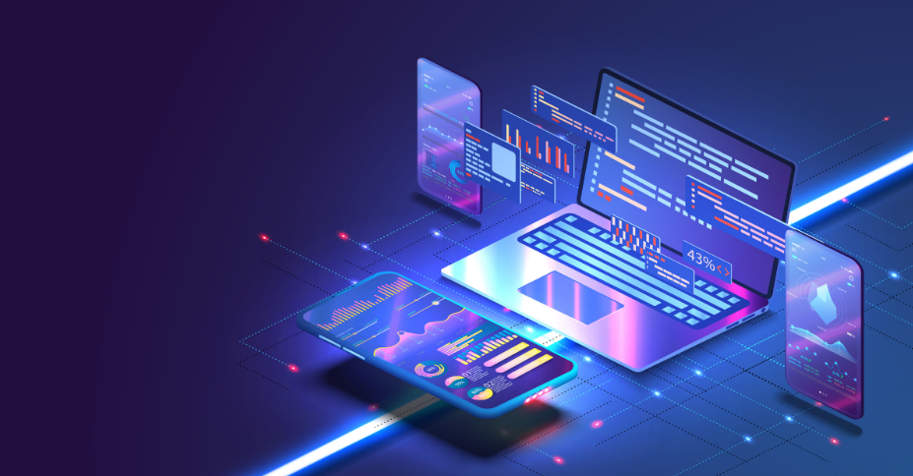

**What can you build with no-code tools?**

Technology has been a major driver of cultural, financial, and social development for humanity. Inventions such as autos, phones, the internet, and computers were all created by being available to a few people, but currently are available to almost everyone. The no-code tools movement is looking to take the idea of mass production further by making it comfier for non-programmers to make use of and create software.

The vision of no-code tools software and development has been about for decades. Those of us old enough to remember the days of DOS know the struggle of needing to understand programming to use a computer. Those a bit more youthful might remember creating a Geocities unique website using HTML, while you can now easily create a site in minutes without HTML.

These low and no-code tools have made it more comfortable for individuals to fulfill complex procedures with little to no technical knowledge. Processes like creating a corporate site, managing HR matters, and updating inventories can be easily implemented by organizations.

Software development is no easy business and, as such, requires specialized ability to be built from the ground up. With hundreds of programming languages, platforms, and hardware constraints, most businesses will have to hire one or several programmers. This, of course, means that you will spend your time and effort.

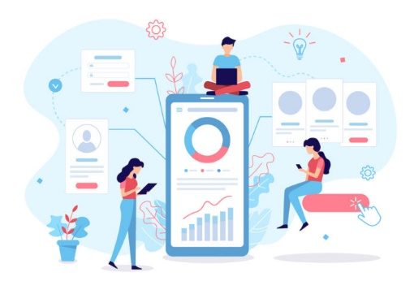

**What are 3 examples of no-code tools?**

We are a no-code tools  [AppMaster](https://appmaster.io/blog/full-guide-on-no-code-low-code-app-development-for-2022" \t "_blank) (https://appmaster.io/). We are more than just no-code; the uniqueness lies in the fact that we generate the source code. This means that the user can not be afraid to be tied to the platform if they want; they can always take their source code. Moreover, our platform can write technical documentation in the same way as developers (humans) do. But we are better than the whole team of developers; we are faster, better, and cheaper. The platform generates 22,000 lines of code per second. Man is not capable of such a result. Our backend is written in Golang (yes, guys, we have a backend).

On our platform, you can create:

• web applications

• mobile applications

• and, of course, there is a backend (the most powerful backend no-code tools in existence)

Advantages of No-Code tools :

**Reduce Costs**

No-code solutions reduce the cost of development by up to 80%. No-code tools close the IT gap without having to incur additional resource expenses.

**Increase Speed**

The time to develop an app takes months. Developers and businesses are looking for ways to deliver apps faster. No-code cuts this time in half or even less.

**Stay Ahead**

No-code tools

is the future. Businesses that implement it today, stay ahead of the curve. No-code is a perfect tool for continuous improvement.

**Make Better Apps**

Development with no-code tools results in a better success rate for apps. Create applications much faster and receive instant feedback.

**Accelerate Operations**

No-code tools are a perfect touchpoint for your team. Build, start and process workflows without wasting time on monotonous, routine tasks.

**Increase Agility**

Efficient and fast development via visual modeling tools allows businesses to adapt quickly to changing markets and customer demands.

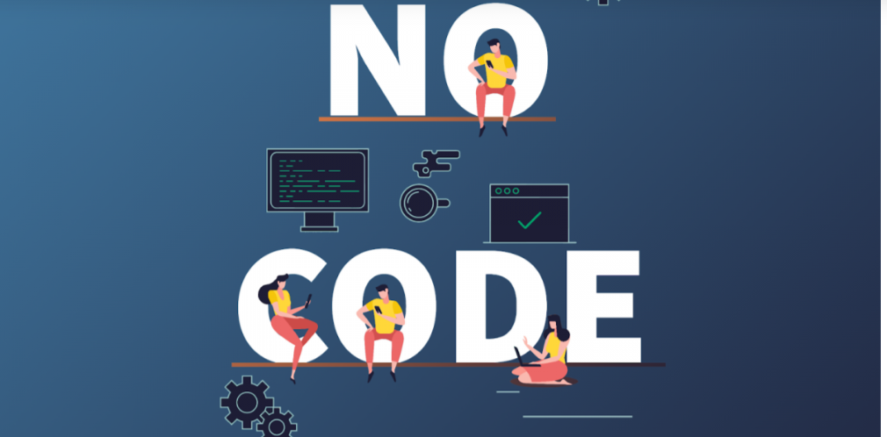

**What is no-code automation tools?**

Today, there is almost no limitation to what you can create with a no-code tool.

You can automate your work or home tasks with no code automation tools, you can manage your data, or you can get paid via no-code.

Without automation, so many businesses would be doomed to go bankrupt.

Everyone wants everything right, quickly, and on time now, and it is no human task to make that wish come true.

So, we need no-code automation. And no-code automation specifically, because automation and the rest of the tasks in all businesses have become so intertwined that everybody needs to make automation for their own needs now.

So yes, no code automation tools like [App Master](https://appmaster.io/blog/what-is-visual-programming-and-how-does-it-work) are here to stay.



--------------------------------------------------------------------------------------------------------------------------------------

This is a title :

**How no-code tools can automate Your Small Business**

This is a ***meta description of the article***:

AppMaster No-Code twill make all your ideas come true. A website to discover the latest tools, techniques, and projects to build without any coding knowledge!